

**<**

Contact:

**Angelo Virgilio**

[Angelo.virgilio@ecin.ca](mailto:Angelo.virgilio@ecin.ca)

Mobile: 416.605.1296

Wifi automation – ROBOT AUTOMATION – User MANUAL

Bell Canada; ATL Lab

|  |
| --- |
| **Revisions** |

| Version | Primary Author(s) | Description of Version | Date Completed |
| --- | --- | --- | --- |
| 0.1  0.2  0.3  1.0  2.0 | Arijit Saha  Angelo Virgilio  Angelo Virgilio  Arijit Saha  Arijit Saha | First Draft version  Added template, formatted and updated various sections  Added New Section - Next steps  User Manual – Complete description for MySQL Project  Final Version – Robot Automation Project (Integrated) | May 30, 2017  June 2, 2017  June 7, 2017  Aug 15, 2017  Oct 18. 2017 |

|  |
| --- |
| **Review & Approval** |

Requirements Document Approval History

| Approving Party | Version Approved | Signature | Date |
| --- | --- | --- | --- |
| **Bell Canada:**  **Bertrand Camus**  **Intissar Harrabi** | 0.3 |  |  |
|  |  |  |  |

Requirements Document Review History

| Reviewer | Version Reviewed | Signature | Date |
| --- | --- | --- | --- |
| **Angelo Virgilio** | 0.3 |  | June 9, 2017 |
|  |  |  |  |
|  |  |  |  |

Contents

1. Open RIDE GUI 4

2. Load Project in RIDE 5

3. Test Suite Management 9

4. Test Case Management 10

5. Configuring Result Arguments 11

6. Configuration and Execution of MySQL Store Result test case 12

7. Truncate data from tables in database 15

8. Configuration for Predefined TestCases All 18

9. Configuration for User Defined Test Suite 19

10. Test Case Copy and Reorder 20

11. Configuring Common Parameter 21

12. Generate TestCases Test Suite 23

13. Generate TestCases_ALL Test Case 24

14. Configuring Test Parameters 25

15. Running “Generate_TestCases” test suite. 26

16. Test Parameter Validation 27

17. Test Parameter Dependency Validation 28

18. Running “Generate_TestCases” test suite. 29

19. Test Command Generation Directory 30

20. Test Command Generation 31

21. Generate_TestCases_All test case Execution Progress 32

22. Selecting Test cases to Execute 33

23. SSH and SCP to Wave Automation Server 34

24. Detecting test case completion and failure in Wave Automation 35

25. Storing Wave Automation test case execution time 36

26. Finding Wave Automation test case execution time 37

27. Executing TP test cases (dynamic) 38

28. Selecting Test cases for execution 39

29. Getting Wave Automation timestamp result directory name 40

30. MySQL Integration 41

31. Obtain Loads dynamically for LAT and RR test cases 42

32. Executing LAT test cases (dynamic) 43

33. Executing RR test cases (dynamic) 44

34. Executing MaxClient test cases (dynamic) 45

35. Creating and selecting user defined test cases for execution 46

36. ROBOT Automation execution time 48

37. Saving PCAP files 49

38. Enabling Debug 50

39. Test Execution Progress 51

40. Robot Automation Post Execution Logs 52

41. Robot Automation test report 53

42. Configuring Backup Script 54

43. Executing Backup Script 56

44. Configuring Copy Script 57

45. Executing Copy Script 58

46. Database Backup 59

47. MySQL Database Management 60

48. MySQL Script Execution Progress 64

49. MySQL Script Post Execution Logs 65

1. Open RIDE GUI

In order to view and execute the test cases, the user needs to open the RIDE GUI from the shortcut named “ROBOT Automation RIDE” which is present on the Desktop.

1. Double click on the shortcut icon to open the RIDE GUI.

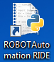

1. RIDE GUI should open.

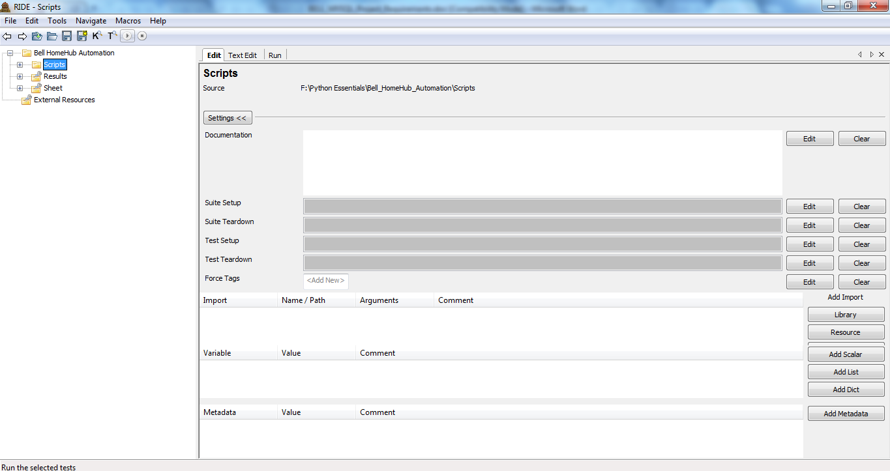

Note: Creation of shortcut has been mentioned in the installation document section 2.7.1.

1. Load Project in RIDE

After the RIDE GUI opens, the user needs to load the project folder so that they get the view of the test case structure and the different test cases that are present for execution.

* + Copy the “**Bell HomeHub Automation DB Creation.zip**” provided along the document to root folder “**C:\**”.
  + Extract the folder to “**C:\**” as shown.

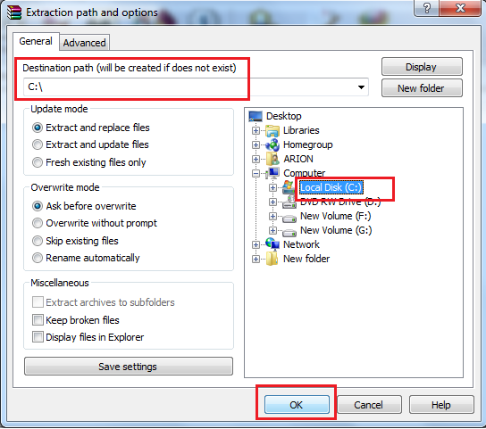

* + After extracting the folder, a list of folders as shown in below picture should be present.

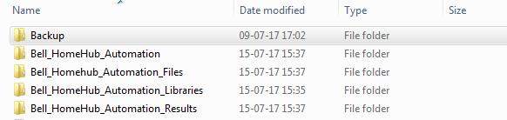

* + Now on the RIDE GUI, click on **“File”** and click on **“Open Directory”** to open the file system and choose the project to be loaded from local folder.

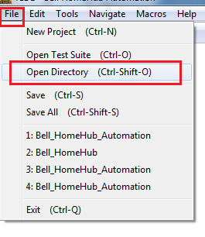

* + From the window that opens, click to expand the contents of drive **“C:\”.**

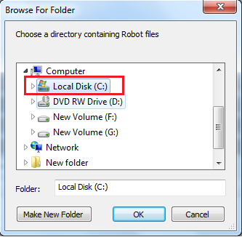

* + After the contents of the driver expand, click on **“Bell HomeHub Automation”** folder again to expand and show the contents.

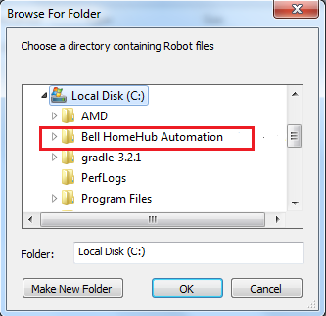

* + As the folder contents expand, click on **“Bell_HomeHub_Automation”** folder to select.

Click **“Ok”** button.

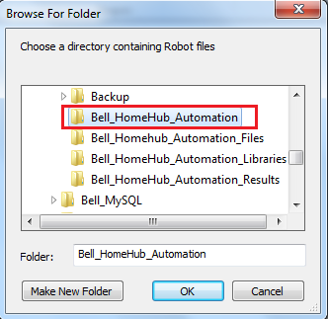

* + The RIDE GUI will have the contents loaded as shown.

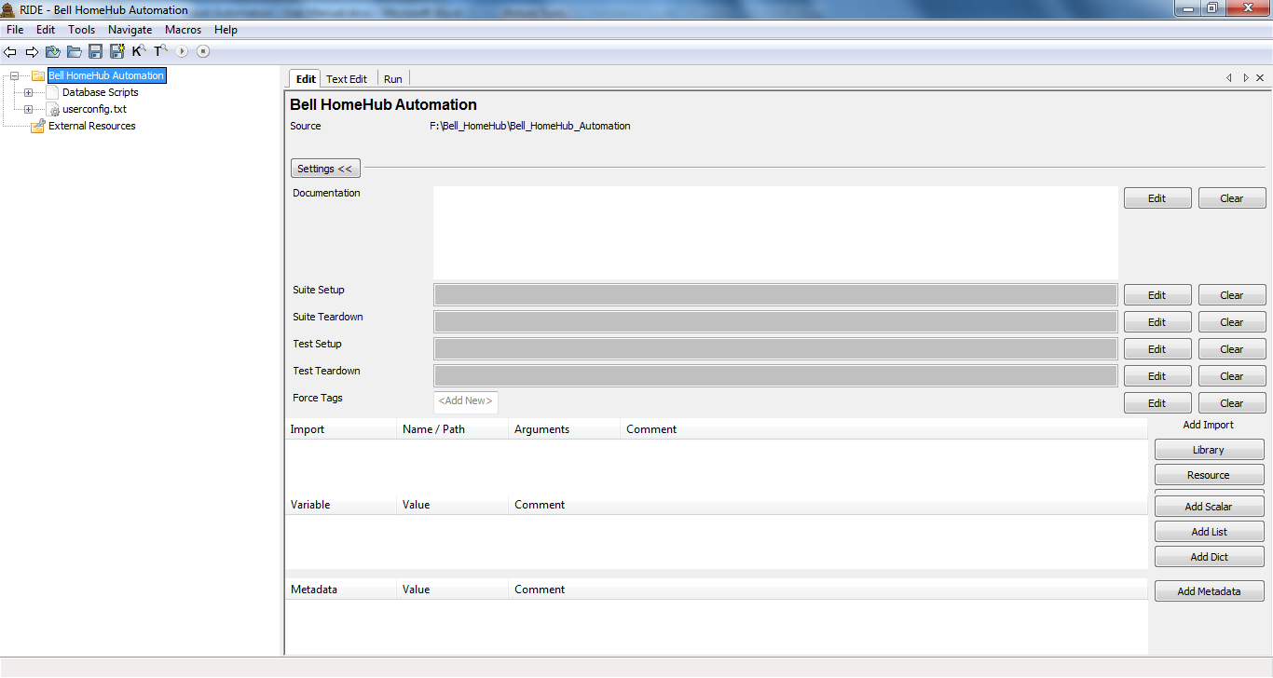

1. Test Suite Management
   * + - 1. Right-click on project name which will be there on the top left of the screen and click on “**New Suite**” option.

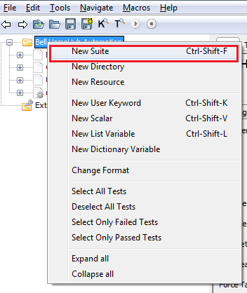

1. In the box that appears, enter the name of the Test Suite, select radio button “**File**” for **Type** and “**ROBOT**” for **Format.**

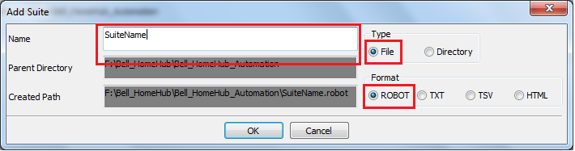

1. Test Case Management
   * + - 1. Right-click on test suite name and click on “**New Test Case**” option.

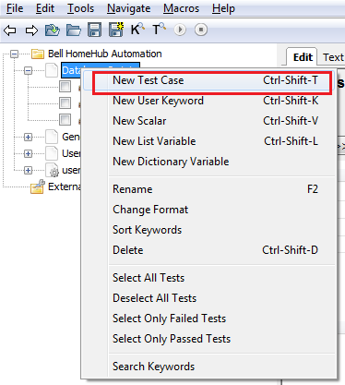

* + - * 1. Enter the test case name in the window that pops up and click on Ok button.

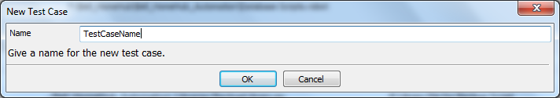

1. Configuring Result Arguments

The section aims to customize the result files name, location and the background colour.

Command: **“-d ..\\Bell_HomeHub_Automation_Results --timestamp --reportbackground white:white:white**”

The above command needs to be inserted in the arguments section, following the steps:

* 1. Click on project name.

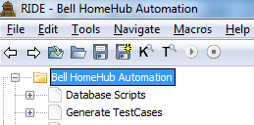

* 1. Click on **Run** tab.

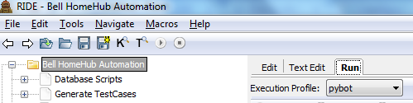

* 1. Copy the above mentioned command and paste it in arguments text area as shown.

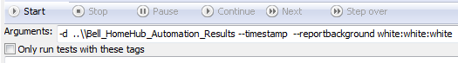

* 1. Select **Execution Profile** as **pybot** (if not already selected).

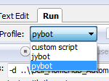

* 1. Click to checkbox to mark as selected for **Show message log** (if not already selected).



1. Configuration and Execution of MySQL Store Result test case
2. Click on **“Database Scripts”** test suite and expand to view the test cases in it.

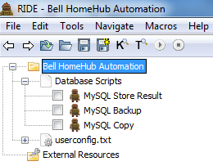

1. Click on **“MySQL Store Result”** to select. On the right half of the screen, the **Edit** tab will open and show the contents as seen in the picture below.

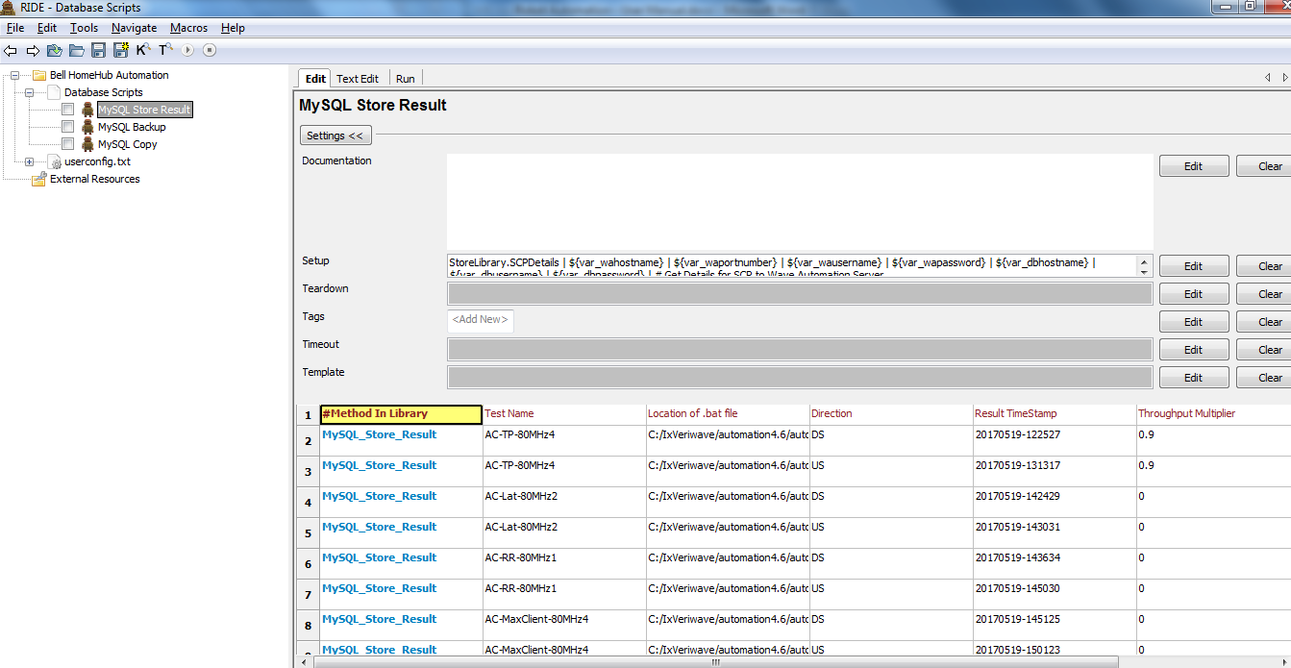

1. Configuration for the test cases include :
   * **Test Name** – Name of the test case. Example –> AC-TP-80MHz**.**
   * **Location of .bat file** – Location of .bat on Wave Automation Server for the test case mentioned above. Example- >C:/IxVeriwave/automation4.6/automation/conf/H3000/HH3000-Rel1_2_3-auto_conf.bat.

**Note**: File path should contain front slash only as shown in example and should contain name of .bat file.

* + **Direction** – Direction mentioned in the test case. Example -> DS for Downstream.
  + **Result TimeStamp**– TimeStamp created during the test execution for storing results for the particular test case. Example-> 20170519-142612.
  + **Throughput Multiplier** – Value for throughput multiplier applicable for TP test cases only. Other test cases have value 0.

**Enter values for each row for the test cases that needs to be executed.**

1. Select the **MySQL Store Result** test case by clicking on the checkbox on the left of it.

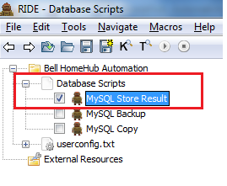

1. Click on **Run** button to start execution of the test case.

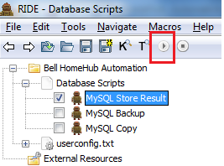

1. Truncate data from tables in database

**NOTE:** TRUNCATE operations cannot be undone or rolled back.

* 1. Click to select the tables that need to be truncated from the Navigator window on the left pane of MySQL Workbench.

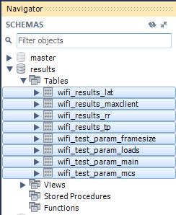

* 1. Right click the mouse button keeping the pointer on the selected table names. A menu box will appear.

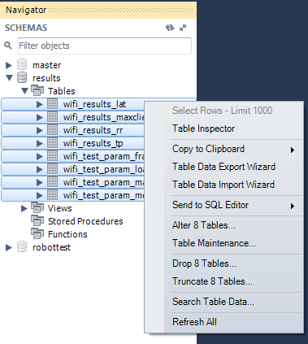

* 1. Click **Truncate Tables** options present on the pop up menu bar.

**Note:** The number of tables to be truncated will be shown which will depict the number of tables selected. For example it shows “Truncate 8 Tables” in the picture below.

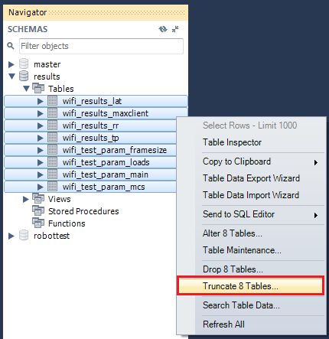

* 1. Click **Truncate** on the confirmation box.

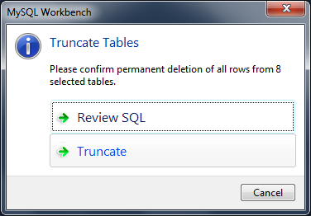

* 1. It might take a couple of seconds based on the amount of data to be truncated.

Upon refreshing/ reopening the table contents, a clear table will be seen.

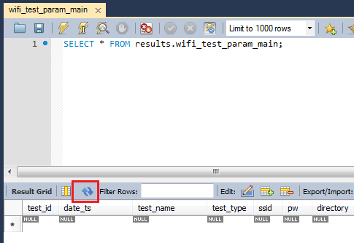

1. Configuration for Predefined TestCases All

**Note:** There are 8 test suites named by the type of test cases they have in them.

For example:

* + - * 1. Click on **“TS1_Throughput_5G”** test suite and expand to view the test cases in it.

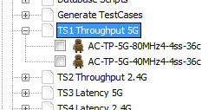

* + - * 1. Click on **“TS2_Throughput_2.4G”** test suite and expand to view the test cases in it.

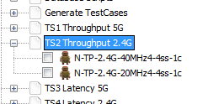

* + - * 1. Click on any other test suites present in the left block. The user will be able to see two test cases of the particular type present under each of the test suites.

1. Configuration for User Defined Test Suite
   * + - 1. Click on **“User1 TestSuite”** test suite and expand to view the test cases in it.

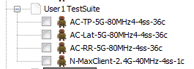

1. Click on **“AC-TP-80Mhz3”** to select. On the right half of the screen, the **Edit** tab will open and show the contents as seen in the picture below.

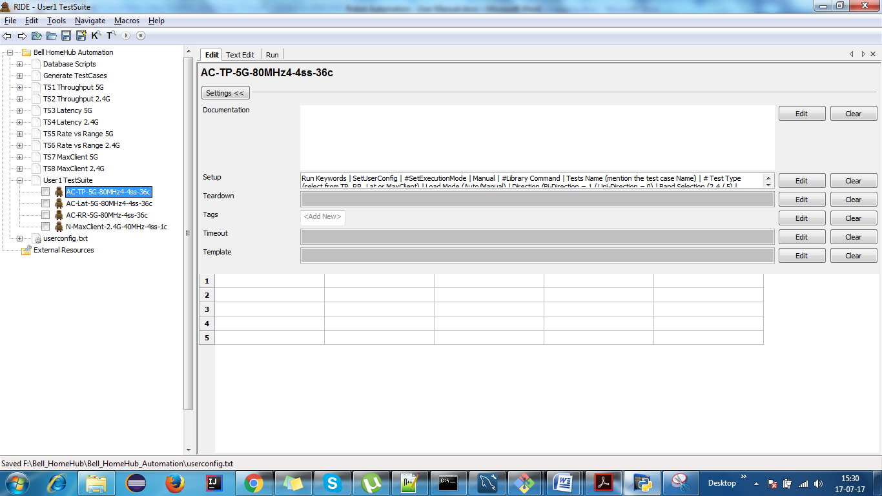

1. Enter the values as mentioned in the labels above for each.
2. Test Case Copy and Reorder
   * + - 1. Click on Test Case Name that needs to be copied and drag it to the test suite to copy to.

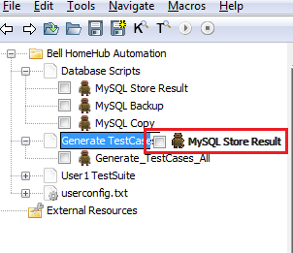

* + - * 1. To reorder, select a test case and right click on it. Click on Move Up/ Move Down option.

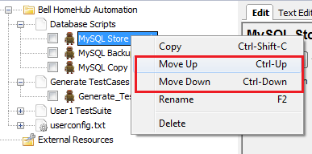

1. Configuring Common Parameter

User can enter common parameters values that are used by all test suites and test cases in userconfig.txt file.

1. The label for the parameter will be present on the right under comments column, followed by the description of the same.



1. The default value for the parameter will be present under **Value**column. Click on the row to enter the modified value for the particular parameter. It opens a pop up window.

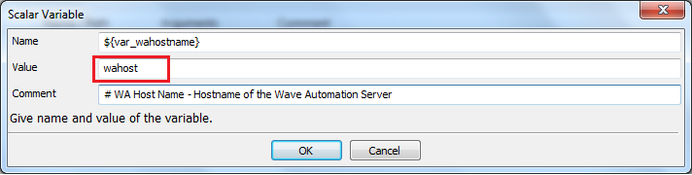

1. In the text box for **Value**, remove the default value and type in the actual value for the environment. Click Ok.

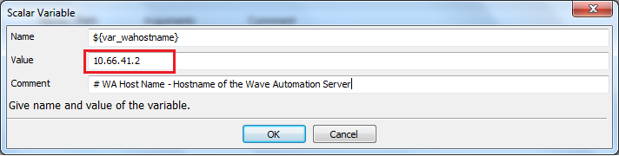

1. In the similar way, all the parameters present in the file as shown below can be configured by the user.

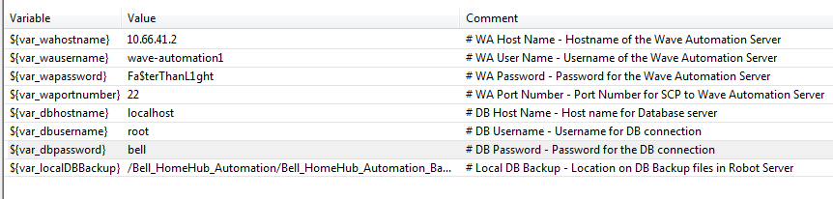

1. Generate TestCases Test Suite

Generate TestCases Test suite contains the list of all Test cases and Test parameters needs to be passed to create test commands.

In order to create the suite, the user needs to follow the steps.

1. Right click on the name of the project and click on **New Suite**.

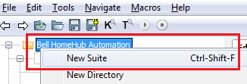

1. As the window appears type in “**Generate TestCases**” in the pop up window.

Click **Robot** radio button to specify the format.

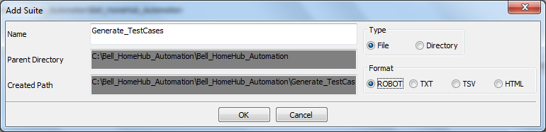

1. User will be able to see a test cases being created under the project.

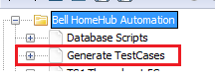

1. Generate TestCases_ALL Test Case

Generate_TestCases_All creates test commands for all test cases per user configuration for Throughput, Latency, Rate_vs_Range and MaxClient.

The user needs to create the test case file under the **Generate_TestCases** test suite.

In order to create the suite, the user needs to follow the steps.

1. Right click on **Generate_TestCases** test suite and click on **New Test Case**.

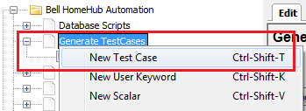

1. Enter the name of the test case in the box that appears and click Ok.

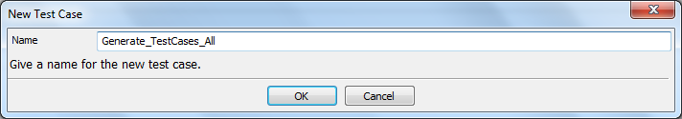

1. User will be able to see a test case being generated under the test suite.

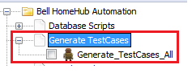

1. After creating Generate_TestCases_All in Setup enter following command.

“Run Keywords | SetUserConfig | AND | SetExecutionMode | Auto” Which will setup the required parameters for execution.

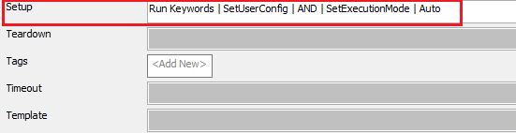

1. Configuring Test Parameters

Users will be able to enter test parameters that are specific for creating test commands for the mentioned test cases.

1. Users can enter the values based on the labels mentioned at the top for **Library Command**.



1. User will be able to click on the cell and type in the value where each row refers the data for a .bat file.



1. Running “Generate_TestCases” test suite.
   1. User needs to configure the parameters for the Generate_TestCases test suite as shown. (Refer 13. Configuring Test Parameters)
   2. Select the checkbox for “**Generate_TestCases_All**” test case under “**Generate_TestCases**” test suite as shown in figure and click **Run** button.

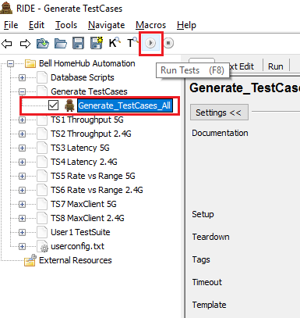

1. Test Parameter Validation
   1. User clicks on **Run** button to execute “**Generate_TestCases_All”** test case.
   2. Robot Automation will check to validate all input test parameters entered by the user at the time of configuration. Ex: as shown in picture below, the value for Band Selection is invalid.

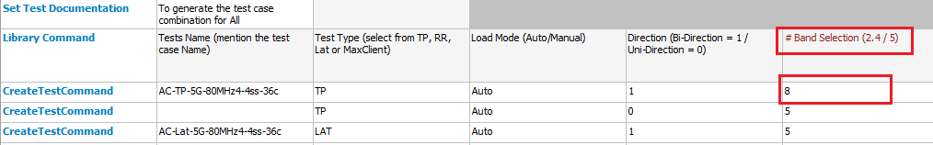

* 1. When Robot Automation finds a value entered by used is not in range or is invalid, it will show the error and abort the Test Case generation process.

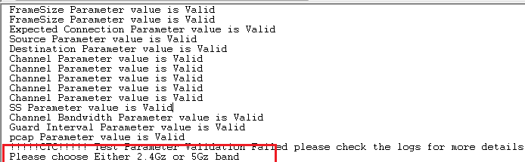

* 1. After the validation check, if no errors for parameters entered are found, the logs will show a success message.

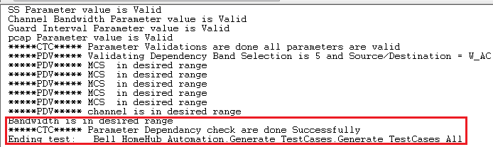

1. Test Parameter Dependency Validation

User can configure various test types in the Generate_TestCases_All test case. When the user enters the values, the dependent test parameters will also be checked.

* 1. The user enters values to configure test command for TP test cases. The values like “**ss**”, “**mcs**” and “**framesize**” are the test case dependent values.
  2. When the user enters test case parameter values for LAT or RR, Robot Automation will check the values for “ss”, “mcs” and “framesize” which **should be** **same or a subset of the values for the equivalent TP test cases parameter values**.
  3. Robot Automation will validate the values and show error log on the screen when the values are not in valid range. Robot Automation will show success when the values are in expected valid range.

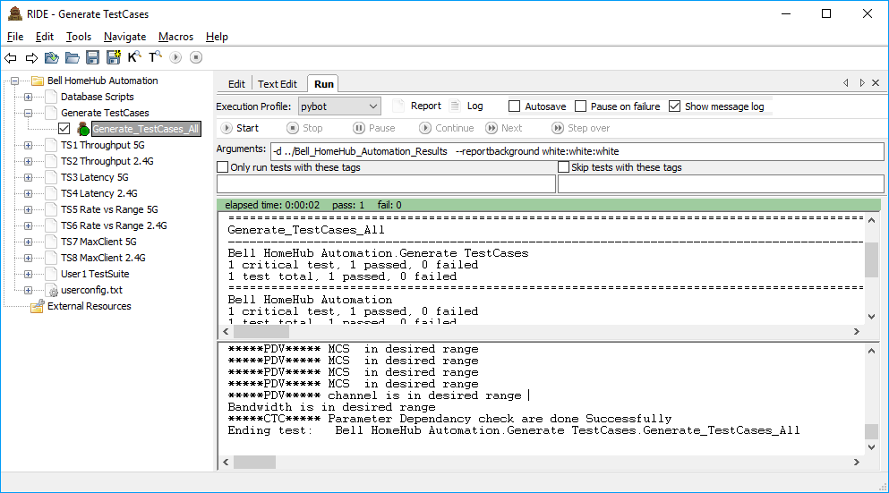

1. Running “Generate_TestCases” test suite.

After configuring test parameters select the “Generate_TestCases” test suite as shown in figure and click on Run button.



When user click on Run button, Robot Automation Framework first validates the input test parameters and if any value entered by used is not in range framework will highlight the error and abort the Test Case generation process.

After Test parameter validation succeeded Robot Automation Framework will execute the Parameter Dependency validation check. If Parameter Dependency check failed then Framework will highlight the error and abort the execution Process

1. Test Command Generation Directory

Upon successful validation of test parameters and dependencies entered by user, the Test command directory will be created. To create the directory, user needs to set the value of “SetExecutionMode” to “Auto”.

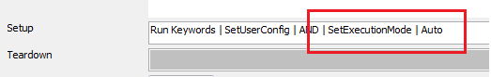

The test command files will get stored under following project directory “Bell_HomeHub_Automation\Bell_Homehub_Automation_TestCommand”. A new directory will be created named by execution timestamp value in format “TC_<YYYYMMDD-HHMMSS>”.

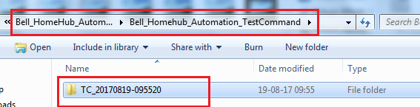

For every execution of “Generate_Testcases_ALL” test case, ROBOT Automation will create a new directory with current timestamp and store test command files in it as shown above.

1. Test Command Generation

Upon successful validation of test input values by the user, a directory with current execution timestamp value will be created and the test command files will be stored in it.

The test command files created will be based on the user input values and the user will be able to enter values to create four types of test command files as mentioned below:

1. Throughput (TP)
2. Latency (LAT)
3. Rate Vs. Range (RR)
4. MaxClient.

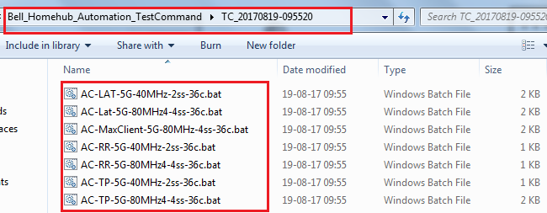

1. Generate_TestCases_All test case Execution Progress

When user starts execution by pressing “Run” button, the execution progress will be shown to the user along with the logs in details

The processes that will execute on starting it are:

* 1. Validation of user input values and dependencies.
  2. Creation of test command directory to store the files named by current timestamp.
  3. Creation of test command and stored in the folder in particular folder created.

For details refer following figure.

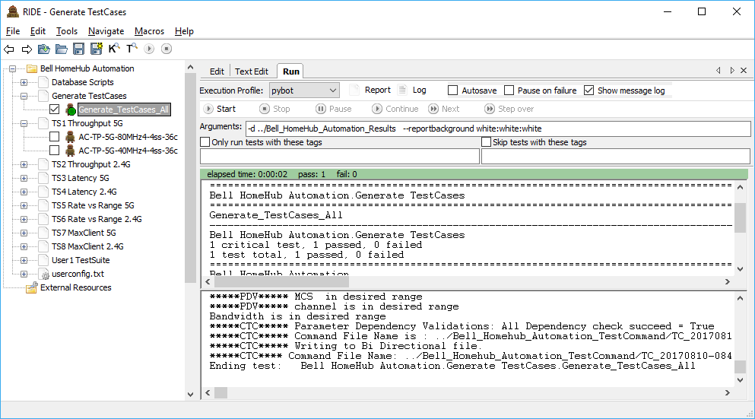

The execution status will show “Pass” when all the points mentioned above will get executed properly.

1. Selecting Test cases to Execute

ROBOT Automation provided options for users to select the list of test cases to execute as shown in the figure below.

User can select both “Generate_Testcases_ALL” test case along with actual test cases below like N-TP-2.4G-40MHz-4ss-11c and execute them, or execute “Generate_TestCases_All” and then select specific test cases to execute individually.

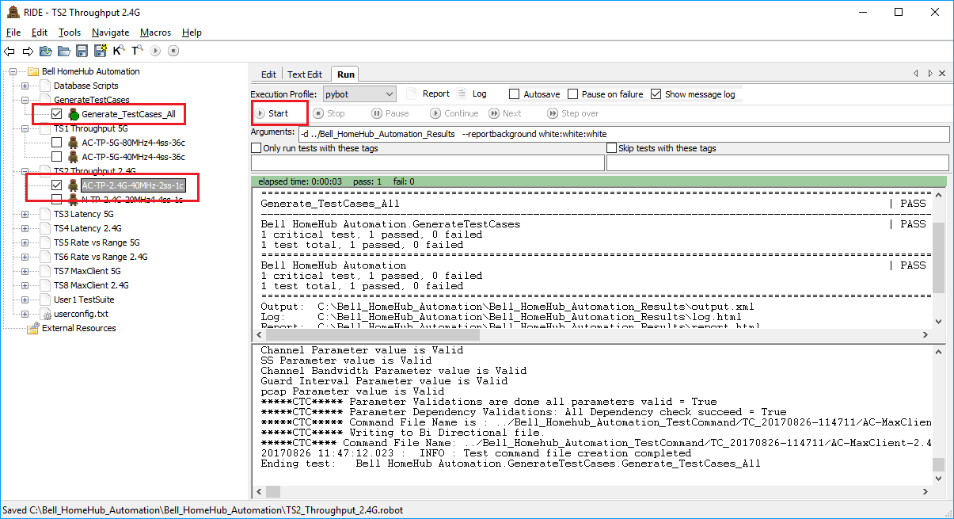

1. SSH and SCP to Wave Automation Server

When user selects test case for execution, ROBOT Automation will create the .bat command file in “Bell_HomeHub_Automation\Bell_Homehub_Automation_TestCommand” as shown in section 20.

The generated .bat will be copied to Wave Automation server using the “Secure Copy” method, i.e. SCP. Once the .bat command file is copied on server, the respective command for the test case in the .bat file will start to execute.

In order to execute the command file on Wave Automation server, ROBOT Automation framework will create secure SSH connection between them and start execute the command file on the Ixia chassis. User will be able to configure the server details and SSH details for the execution to take place in the userconfig.txt file (Refer Section 11 Configuring Common Parameter).

1. Detecting test case completion and failure in Wave Automation

After copying .bat command file on Wave Server, ROBOT Automation framework will execute the command file. During the execution of the command file on the Wave Automation server, a temporary file will be created to fetch the details getting printed on the console.

On completion of the execution, ROBOT Automation framework will again copy the temporary file created from Wave Automation server and parse it.

The application will parse every line of the file so that It gets all the necessary details from it. It will fetch details like:

* 1. Duration of test case execution on Ixia Server.
  2. Location of result files
  3. Status of the test execution.

1. Storing Wave Automation test case execution time

For each executed test case, the time taken to execute (test duration) of the test case is calculated and it stored in text file temporarily. The value will be visible to the user in the database on a permanent basis.

Upon integration with MySQL Store Script. the value will also be placed in the database where under “test_duration” column in ‘wifi_test_param_main’ table.

1. Finding Wave Automation test case execution time

ROBOT Automation Framework will parse the execution log file to identify the total execution time. The logic is explained below:

#### Starting automated test run at **20170519-150123** - (Store in **<var_testcase_starttime>** )

#### Automated test run completed at **20170519-151121** – (Store in **<var_testcase_endtime>**

Then calculate the test duration:

<var_testdutation> = <var_testcase_starttime> - <var_testcase_endtime>

1. Executing TP test cases (dynamic)

Note: Execution of TP test cases is a must before executing corresponding LAT and RR test cases. Steps to execute TP test case is explained below:

Let us consider AC-TP-80MHz3 user test case, the logic that will be implemented for execution are:

* 1. ROBOT Automation will look for the latest folder created (named by timestamp) under “**Bell_HomeHub_Automation\Bell_Homehub_Automation_TestCommand”**.
  2. Check for ‘.bat’ files created based on the number of commands entered in “Generate_Testcases_ALL” test case. It will proceed with execution if the file is present, else shows an error to the user.
  3. Secure copy the .bat file created to the Wave Automation Server and place it in the directory for the execution on Ixia chassis.
  4. Establish secure connection and execute the .bat file over SSH.
  5. Detection of completion status of the execution. A successful execution status will make the ROBOT Automation carry on with the following tasks, else will show an error to the user, stating the reason on a failure.

1. Selecting Test cases for execution

ROBOT Automation will allow user to select individual or group of test cases within a test suite or multiple test suites for execution and click on “Run” to execute them.

User can select test cases to generate test commands and execute. The sample screenshot is shown below.



1. Getting Wave Automation timestamp result directory name

ROBOT Automation will read the data that gets printed on the console while the test case gets executed over SSH. The entire data of the prompt will be redirected to a temporary file that will be created called output.log.

ROBOT Automation securely copies the file from the Wave Automation server and reads the entire contents. The timestamp folder where the results values will be found, is parsed and fetched from the file itself.

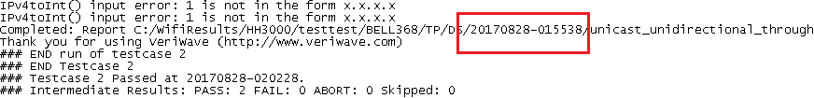

1. MySQL Integration

ROBOT Automation will integrate the MySQL scripts where the data from the results file will be stored into the database automatically after execution of the test command on the Wave Automation server.

When the execution of the test case completes on the Wave Automation server, the output.log file will be parsed and the folder where the results are stored will be fetched.

Then the MySQL Store Result script will be called automatically which will extract the data from the .bat files and store in the respective tables. The corresponding result .csv files will also be fetched and parsed.

After the data is fetched and calculations are done if required, the fetched data from the result .csv files will be stored in the database.

1. Obtain Loads dynamically for LAT and RR test cases

To obtain the value for loads field in LAT and RR, the user needs to execute the corresponding TP test case first. For example, if the user plans to execute “N-LAT-2.4G-40MHz-1ss-1c-7mcs”, first the execution of “N-TP-2.4G-40MHz-1ss-1c-7mcs” needs to be carried out. Upon successful execution of the corresponding TP test case, the value of “throughput_pps” will be extracted.

Value of “threshold_throughout_pps” will be calculated which is usually 90% of throughput_pps, else will be calculated based on the input provided by user for “throughput” field when configuring the TP test case.

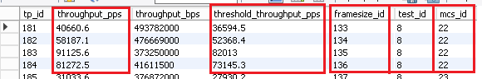

Loads for LAT and RR will be the value of “threshold_throughout_pps” for corresponding TP test case, where the value will be extracted for **each frame size** **against each MCS** value.

For example, **N-TP-2.4G-40MHz-1ss-1c-7mcs** has frame size values “1512 1024 512 64”, and has only one MCS value which is “7”, so **N-LAT-2.4G-40MHz-1ss-1c-7mcs** will have ,loads value for each frame size present in the corresponding TP test case per MCS. So **N-TP-2.4G-40MHz-1ss-1c-7mcs** will have 4 loads values.

1. Executing LAT test cases (dynamic)

Note: Execution of corresponding TP test cases is mandatory before executing a LAT test case. Steps to execute TP test case has been explained above, in section 27.

Let’s consider **N-LAT-2.4G-40MHz-1ss-1c-7mcs** test case to be executed, the logic that will be followed for execution are:

1. ROBOT Automation will look for the latest folder created (named by timestamp) under “**Bell_HomeHub_Automation\Bell_Homehub_Automation_TestCommand”**.
2. Check for ‘.bat’ files created based on the number of commands entered in “Generate_Testcases_ALL” test case. It will proceed with execution if the file is present, else shows an error to the user.
3. Robot Automation will check the successful execution of corresponding TP test case before execution of LAT test case. If it finds a successful execution, then it proceeds to execution LAT else shows an error to the user.
4. Robot Automation will extract “threshold_throughput_pps” value from database for writing the loads value to the .bat file created for LAT test case.
5. Secure copy the .bat file created to the Wave Automation Server and place it in the directory for the execution on Ixia chassis.
6. Establish secure connection and execute the .bat file over SSH.
7. Detection of completion status of the execution. A successful execution status will make the ROBOT Automation carry on with the following tasks, else will show an error to the user, stating the reason on a failure.
8. The MySQL scripts will be called automatically after successful execution of LAT test case of Ixia chassis. MySQL scripts will store data from .bat file in database and also fetch data from Result files for the particular execution and store them in database.
9. Executing RR test cases (dynamic)

Note: Execution of corresponding TP test cases is mandatory before executing a RR test case. Steps to execute TP test case has been explained above, in section 27.

Let’s consider **N-RR-2.4G-40MHz-1ss-1c-7mcs** test case to be executed, the logic that will be followed for execution are:

1. ROBOT Automation will look for the latest folder created (named by timestamp) under “**Bell_HomeHub_Automation\Bell_Homehub_Automation_TestCommand”**.
2. Check for ‘.bat’ files created based on the number of commands entered in “Generate_Testcases_ALL” test case. It will proceed with execution if the file is present, else shows an error to the user.
3. Robot Automation will check the successful execution of corresponding TP test case before execution of RR test case. If it finds a successful execution, then it proceeds to execution RR, else shows an error to the user.
4. Robot Automation will extract “threshold_throughput_pps” value from database for writing the loads value to the .bat file created for RR test case.
5. Secure copy the .bat file created to the Wave Automation Server and place it in the directory for the execution on Ixia chassis.
6. Establish secure connection and execute the .bat file over SSH.
7. Detection of completion status of the execution. A successful execution status will make the ROBOT Automation carry on with the following tasks, else will show an error to the user, stating the reason on a failure.
8. The MySQL scripts will be called automatically after successful execution of RR test case of Ixia chassis. MySQL scripts will store data from .bat file in database and also fetch data from Result files for the particular execution and store them in database.
9. Executing MaxClient test cases (dynamic)

Let’s consider **N-MaxClient-2.4G-40MHz-1ss-1c-7mcs** test case to be executed, the logic that will be followed for execution are:

1. ROBOT Automation will look for the latest folder created (named by timestamp) under “**Bell_HomeHub_Automation\Bell_Homehub_Automation_TestCommand”**.
2. Check for ‘.bat’ files created based on the number of commands entered in “Generate_Testcases_ALL” test case. It will proceed with execution if the file is present, else shows an error to the user.
3. Secure copy the .bat file created to the Wave Automation Server and place it in the directory for the execution on Ixia chassis.
4. Establish secure connection and execute the .bat file over SSH.
5. Detection of completion status of the execution. A successful execution status will make the ROBOT Automation carry on with the following tasks, else will show an error to the user, stating the reason on a failure.
6. The MySQL scripts will be called automatically after successful execution of MaxClient test case of Ixia chassis. MySQL scripts will store data from .bat file in database and also fetch data from Result files for the particular execution and store them in database.
7. Creating and selecting user defined test cases for execution

User will be able to create a Test Case from the RIDE GUI.

1. ROBOT Automation will let the user create the Test Commands by configuring the values for the test cases in Generate_TestCases_All file from RIDE GUI.



1. User can either provide a name for the .bat file that will be generated, else ROBOT Automation will create the name of the .bat file using the parameters provided by the user. For example in the picture shown, ROBOT Automation will create a .bat file by the “CustomName” as entered by user during the creation of .bat file and the second one will be created in the format specified by ROBOT Automation using the parameters entered like “N-LAT-2.4G-40MHz-1ss-1c-7mcs”.

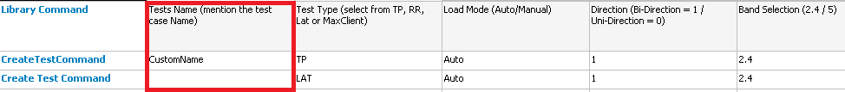

1. Now, the user needs to create a new test case in RIDE GUI (refer Section 4). The user will have to provide the name of the test case by the name of the .bat file created. For example, if the .bat file has been created as “CustomName.bat” , then the name of the test case should be “CustomName” and the scenario remains the same if the bat file is named as “N-LAT-2.4G-40MHz-1ss-1c-7mcs”.
2. User will have to configure certain values in the editable section for the test cases to run. In **Setup** section, “Set User Config” needs to be placed. User can click on the text box and type in the text in the box that appears.

Set Execution Mode needs to be set as Auto.

Execute Test Command needs to be called as shown below for execution of .bat file.

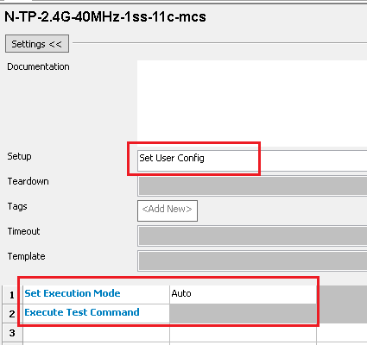

1. User will be able to execute a test case by selecting the check box on the left and clicking on Run button.

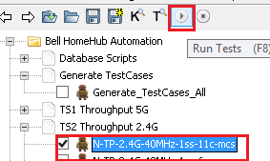

1. ROBOT Automation execution time

User will be able to check the total time taken for each test case to execute on the Ixia Veriwave chassis. The total time will be calculated based on the start time of the execution of each test case from the Robot Automation server. The test case will execute on the Ixia server and after completion Robot Automation will record the completion time too.

The difference will be calculated for each execution and the value will be stored in the database in “wifi_test_param_main" table under column “test_duration”.

**Test Duration = Execution Start Time – Execution End Time.**

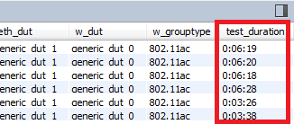

1. Saving PCAP files

User will be able to check PCAP files for each execution. The feature has been made configurable for the user.

The user will be able to configure the value either in “YES” or “NO” when creating the .bat files for each test case from “Generate_TestCases_All” test case.

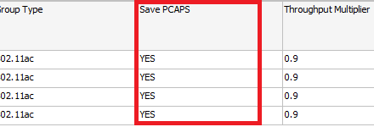

1. Enabling Debug

User will be able to check “debug” parameter in each test command file.

On opening the .bat file created, the user will be able to get the debug parameter configured for the test case.

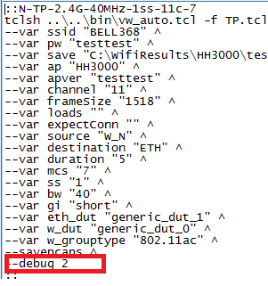

1. Test Execution Progress

User will be able to check the execution progress of the selected test case on the “message log” section of the RIDE execution window.

The progress logs will be shown in a specified format which will help the user understand the portion of the execution which is under progress.

The specified format is:

**<Time> : <Log Level> : <Library Name> -> <Method Name> :: <Log message>**

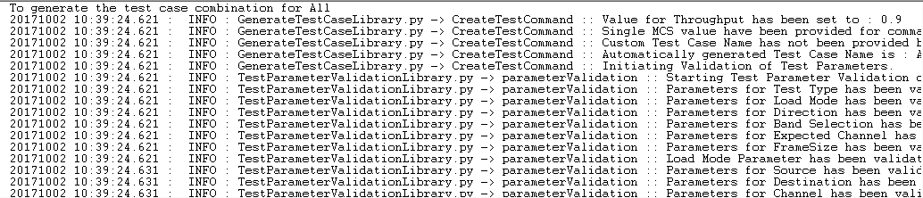

1. Robot Automation Post Execution Logs

User will be able to check the logs of the current execution from the message log section as shown above. For any further reference of the shown logs, user will be able to fetch the same from the folder **C:\Bell_HomeHub_Automation\Bell_HomeHub_Automation_Results\** folder. The files will be named as **log-<YYYYMMDD>-<HHMMSS>.html**.

User will be able to open the log from RIDE by clicking on the button shown in the picture.



A detailed log file is also being created in the background for every execution. User will be able to open the file and read the contents for any clarification process. The file will be generated on a daily basis and will record all the execution data of the entire day in a single file.

The file will be available as: **C:\Bell_HomeHub_Automation\Bell_HomeHub_Automation_Results\DetailedLog_<YYYYMMDD>.log**

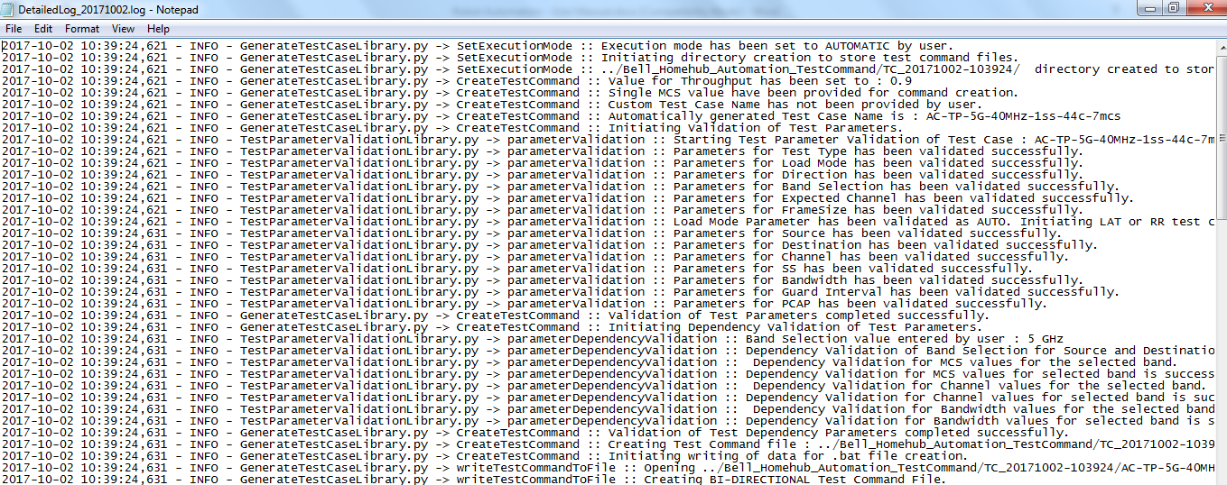

1. Robot Automation test report

User will be able to check the report and status of the current execution from the execution window in RIDE.

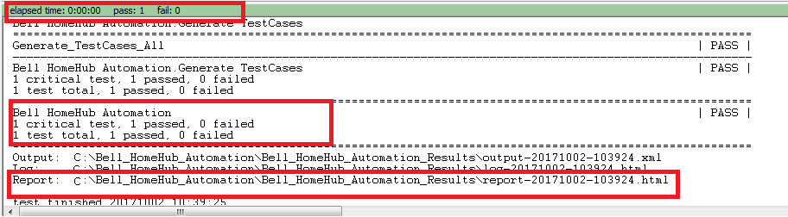

For the details report of the execution, user can click on the Report button on the RIDE and the report file will open in the default browser.



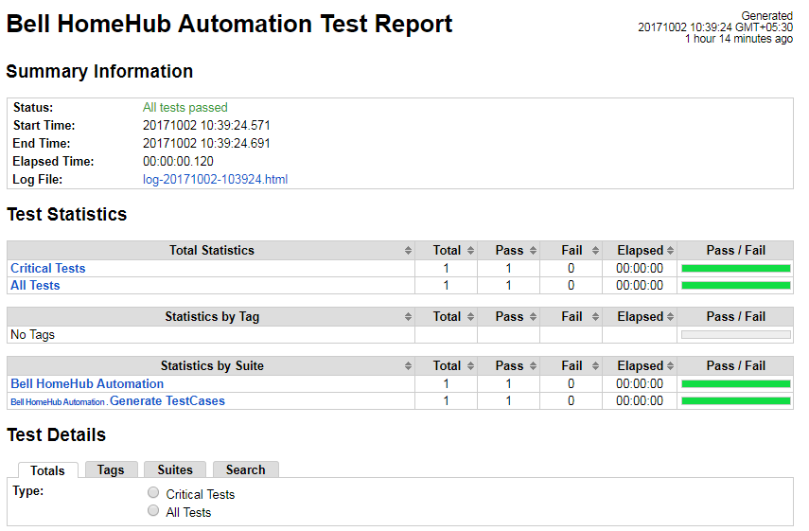

1. Configuring Backup Script

User will be able to configure the values for Database Backup script.

There are two modes in which the backup script will work and the configuration will be as follows:

1. **Automatic Backup Mode**

The parameters for the automatic backup mode are:

* + 1. **Remote Location to store DB Backup –** The parameter will accept the location where the user chooses to store the Backup files of the database on the Wave Automation Server (remote server). For example : C:/DatabaseBackUp/
    2. **Backup Type** - This is where the user chooses the mode of backup out of Automatic or Manual that they want to execute. The user should enter Automatic for this tag when executing Automatic backup.
    3. **Backup Period (In Days)** – This is the value is applicable for Automatic backup type only where it determines the interval at which the scheduled backup task will execute on the Robot Automation server.
    4. **Backup Action** – This value is applicable for Automatic Backup type only and where the expected values are Start and Stop.

**Start** – This is to create a scheduled automatic backup task.

**Stop** – This is to delete an existing scheduled automatic backup task.

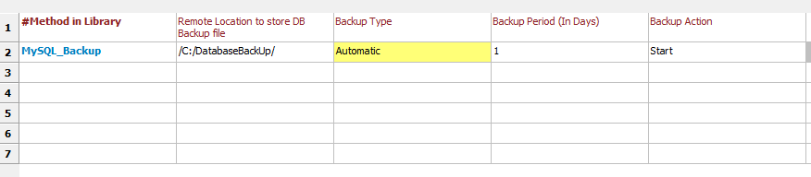

1. **Manual Backup**

The parameters for the automatic backup mode are:

* + 1. **Remote Location to store DB Backup –** The parameter will accept the location where the user chooses to store the Backup files of the database on the Wave Automation Server (remote server). For example : C:/DatabaseBackUp/
    2. **Backup Type -** This is where the user chooses the mode of backup out of Automatic or Manual that they want to execute. The user should enter **Manual** for this tag when executing manual backup.

The other tags can be filled but the values in them will not be used now

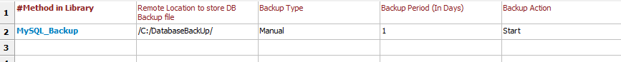

**Configuring server parameters to store Database Backup Files**

* 1. User needs to configure the values for the variables in **userconfig.txt** file.
  2. The values for server configuration include: **Host Name**, **Username**, **Password** and **SCP** **Port** **Number**.



1. Executing Backup Script
   1. User will be able to execute the Backup Script by selecting the checkbox for the Backup script and after the configuration of the values have been completed.

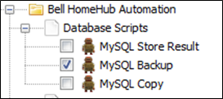

* 1. Click on Run button after choosing the script and the execution will start. User will be able to find the backup files created in Robot Automation and Wave Server.

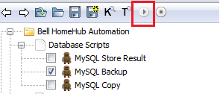

* 1. The configured paths in Robot and Wave server will contain the backup files inside the folder named by execution timestamp.

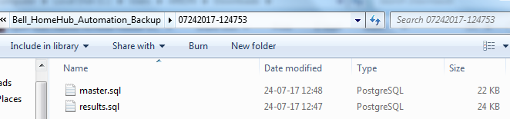

1. Configuring Copy Script

User will be able to configure the values for Database Copy script for project name and test id.

In the Copy script the user will be able enter values for two tags.

a. **Project Name –** User configurable project name in which the user wants to add the specific set of test cases that they want to execute instead of the whole set.

The Project Name will be entered in the database for later use.

b. **Test Case ID –** The user will be able to enter One Test ID from the wifi_test_param_table” in results schema that has been auto generated for the test case that he needs to copy.

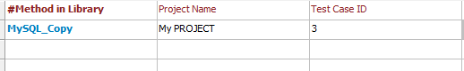

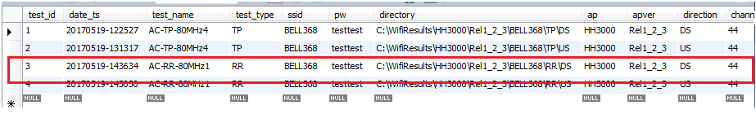

1. Executing Copy Script
   1. User will be able to execute the Copy Script by selecting the checkbox for the Backup script and after the configuration of the values have been completed.

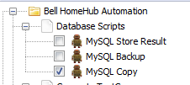

* 1. Click on Run button after choosing the script and the execution will start.

User will be able to find the copied data in the database under master schema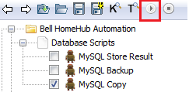

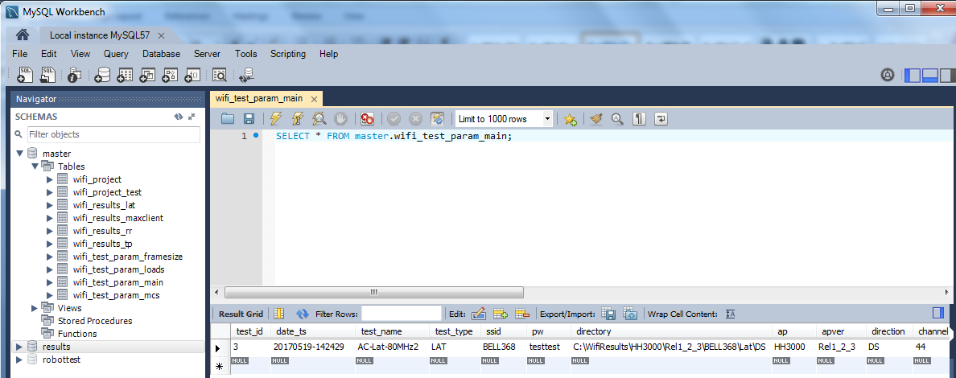

1. Database Backup

User will be able to find the database backup in Wave Automation Server after the execution of database backup script has been completed.

The user needs to configure the folder where the backup should be stored in the RIDE GUI. The user also needs to create the folder structure in the Wave Server. When the execution takes place, the backup files will be stored under the configured folder. A new folder will be created under the parent structure by the latest timestamp value where the backup files will be present

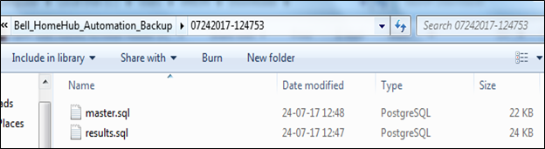

**Automatic Backup Logs:**

* 1. The automatic backup task will execute as per the scheduled task that has been created.
  2. The scheduled task when execute will create a folder as shown above to create and store the database backup files.
  3. User will also be able to find the execution logs of the automatic scheduled task in **Bell_HomeHub_Automation\Bell_HomeHub_Automation_Results** folder.
  4. User will be able to find the success/ failure logs in file named in format **Backup<YYYYMMDD-HHMMSS>.log**.

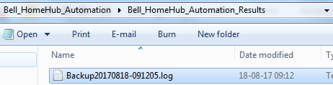

1. MySQL Database Management

There can be multiple user accounts defined for accessing the database based on the rights defined for them. For example, we can create a user as shown below who will not delete rights for the data present in the tables.

1. Login using ‘**root’** id and create new user for automation.
2. On the Workbench, click “**Users and Privileges**”.

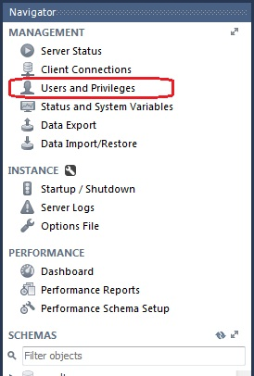

1. Click on Add Account.



1. Enter details for new user as “**autotest1**” in the login name field.

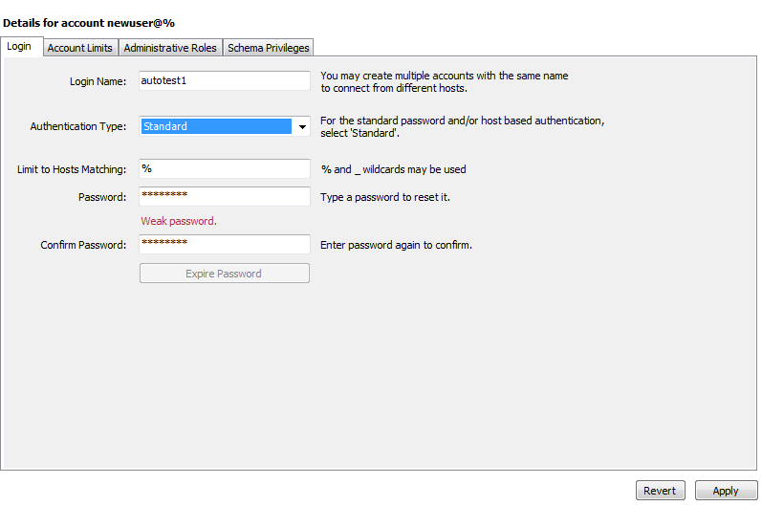

1. Assign the permissions and access levels for the user as **INSERT**, **CREATE**, **UPDATE**.

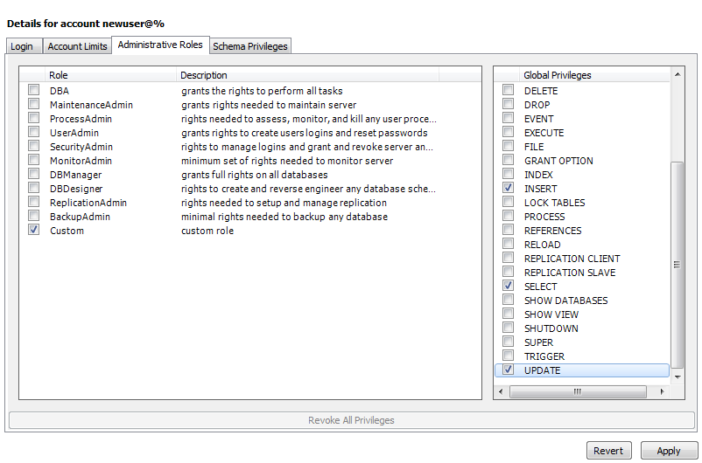

1. Now the user can view the tables and right-click on any row to delete the contents of the row. Click on **Delete Row(s)** option on the drop down.

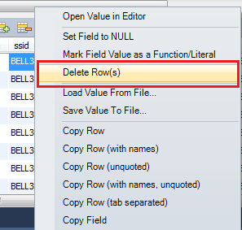

1. Click on **Apply** button

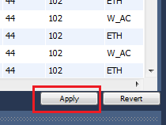

1. Click on **Apply** button again.

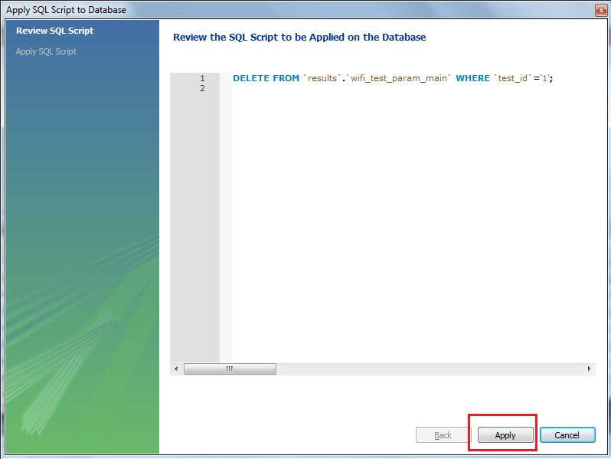

1. The user will get to see the error message and will not be able to perform the action as the privileges have not been set.

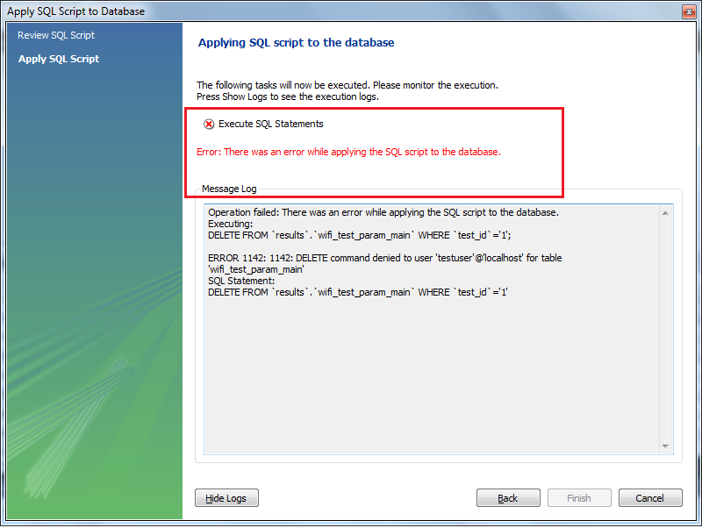

1. MySQL Script Execution Progress
2. The user can choose a test suite by clicking on it. As it expands the test cases in it will be visible.
3. The user then can choose the test case to run by clicking on the checkbox and click Run to start execution as mentioned in previous sections.

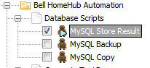

1. As the execution starts, the user will be able to see the execution progress.

The upper part of the screen will show the name of the test suite being executed.

The lower part will show the execution progress logs that will be printed along with the execution steps.

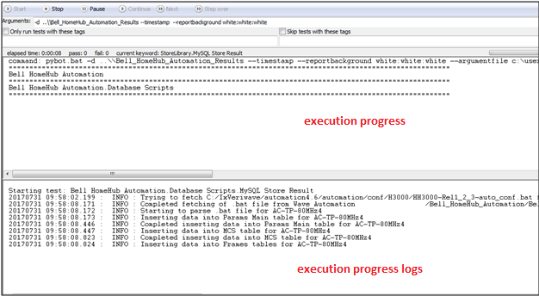

1. MySQL Script Post Execution Logs

The post execution logs will be visible to the user on the screen in RIDE GUI and in a log file created for the steps executed.

* 1. The post execution logs as visible in the RIDE GUI will be present on the lower part of the screen as **message logs.**

**Note:** If the **Show message log** option is not checked, the user will not be able to see the logs on the RIDE GUI screen.

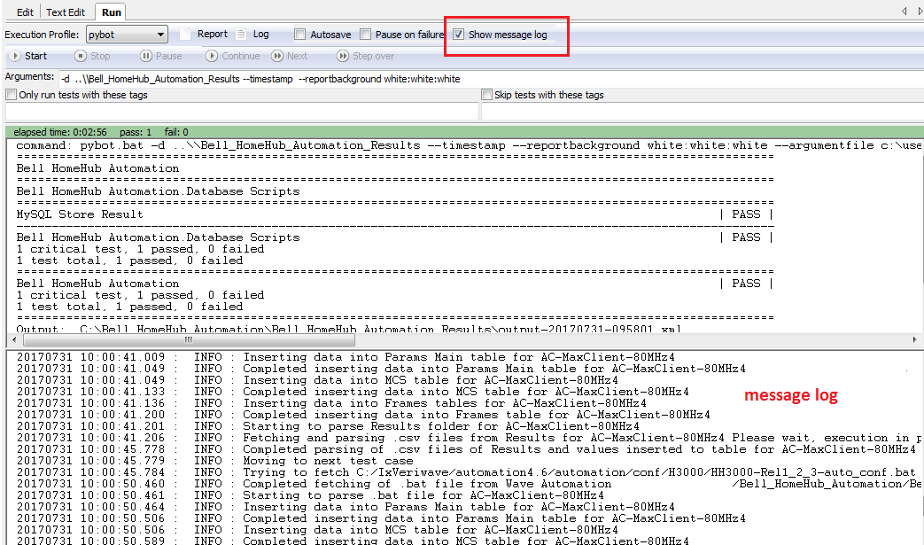

* 1. The user will also be able to see the post execution logs by clicking on **Log** in RIDE GUI.



* 1. As the user clicks, the log file will open in the default browser set for the system.

